**REACT 02**

**AIM:**

Create a react app for Student Management Portal named StudentApp and create a component named Home which will display the Message “Welcome to the Home page of Student Management Portal”. Create another component named About and display the Message “Welcome to the About page of the Student Management Portal”. Create a third component named Contact and display the Message “Welcome to the Contact page of the Student Management Portal”. Call all the three components.

**PROGRAM:**

**ABOUT.js:**

import React from 'react';

import '../App.css';

function About() {

  return (

    <div>

        <h1>BIHER</h1>

      <h2> Welcome to the About page of the Student Management Portal</h2>

      <h3>Bharath Institute of Higher Education</h3>

    </div>

  );

}

export default About;

**HOME.js:**

import React from 'react';

import '../App.css';

function Home() {

  return (

    <div>

        <h1>BIHER</h1>

      <h2> Welcome to the Home page of Student Management Portal</h2>

    </div>

  );

}

export default Home;

**CONTACT.js:**

import React from 'react';

import '../App.css';

function Contact() {

  return (

    <div>

      <h1>BIHER</h1>

      <h2>📞 Welcome to the Contact page of the Student Management Portal BIHER</h2>

    </div>

  );

}

export default Contact;

**APP.js:**

import React from 'react';

import Home from './components/Home';

import About from './components/About';

import Contact from './components/Contact';

function App() {

  return (

    <div className="App">

      <h1 style={{ textAlign: 'center', color: '#2c3e50' }}>

        📚 Student Management Portal

      </h1>

      <Home />

      <About />

      <Contact />

    </div>

  );

}

export default App;

**APP.css:**

body {

  margin: 0;

  padding: 0;

  font-family: 'Segoe UI', Tahoma, Geneva, Verdana, sans-serif;

  background: linear-gradient(to right, #74ebd5, #acb6e5);

  color: #333;

}

.App {

  text-align: center;

  padding: 20px;

}

h1 {

  font-size: 2.5rem;

  margin-bottom: 40px;

  color: #2c3e50;

  text-shadow: 1px 1px 2px white;

}

.card {

  background-color: white;

  border-radius: 12px;

  box-shadow: 0 4px 8px rgba(0, 0, 0, 0.2);

  margin: 20px auto;

  padding: 30px;

  max-width: 500px;

  transition: 0.3s;

}

.card:hover {

  transform: scale(1.02);

  background-color: #f0f8ff;

}

.card h2 {

  color: #2980b9;

  margin-bottom: 0;

}

**OUTPUT 01:**

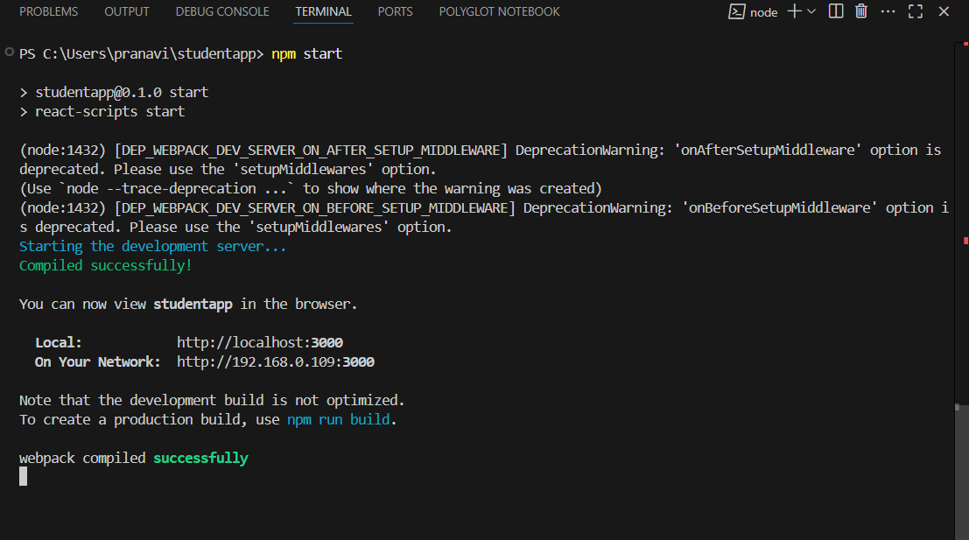

**OUTPUT 02:**

